**Khushal Soni SQL201 Assignment 2**

**DataMart Creation on tutorial.flights on mode.com**

**The output should contain all the attributes as different columns in the datamart created**

Create a DataMart at airline level with different features like

1. Total Number of flights
2. Total Number of delayed flights (Based on arrival delay)
3. Percentage of delayed flights
4. Total Number of cancelled flights (All reasons)
5. Percentage of cancelled flights
6. Give Rank number to each airline based on percentage of delayed flights.
7. Give Rank number to each airline based on number of destinations it covers.
8. Add additional features which can help understand airlines better based on their performance.

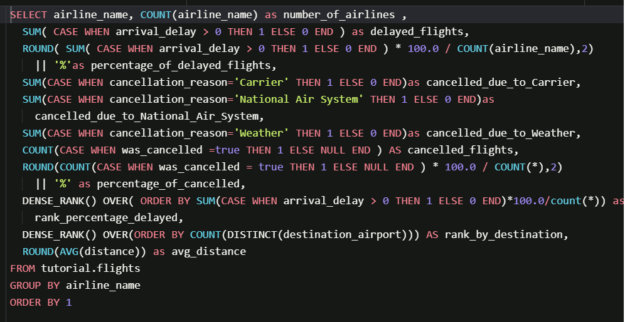

SELECT airline_name,

COUNT(airline_name) AS number_of_airlines ,

SUM(CASE WHEN arrival_delay > 0 THEN 1 ELSE 0 END) AS delayed_flights,

ROUND(SUM(CASE WHEN arrival_delay > 0 THEN 1 ELSE 0 END) * 100.0 / COUNT(airline_name), 2) || '%' AS percentage_of_delayed_flights,

SUM(CASE WHEN cancellation_reason='Carrier' THEN 1 ELSE 0 END) AS cancelled_due_to_Carrier,

SUM(CASE WHEN cancellation_reason='National Air System' THEN 1 ELSE 0 END) AS cancelled_due_to_National_Air_System,

SUM(CASE WHEN cancellation_reason='Weather' THEN 1 ELSE 0 END) AS cancelled_due_to_Weather,

COUNT(CASE WHEN was_cancelled=true THEN 1 ELSE NULL END) AS cancelled_flights,

ROUND(COUNT(CASE WHEN was_cancelled=true THEN 1 ELSE NULL END) * 100.0 / COUNT(*), 2) ||'%' AS percentage_of_cancelled,

DENSE_RANK() OVER(ORDER BY SUM(CASE WHEN arrival_delay > 0 THEN 1 ELSE 0 END)*100.0/count(*)) AS rank_percentage_delayed,

DENSE_RANK() OVER(ORDER BY COUNT(DISTINCT destination_airport)) AS rank_by_destination,

ROUND(AVG(distance)) AS avg_distance

FROM tutorial.flights

GROUP BY airline_name

ORDER BY 1

